Assignment

V model:- It is a type of SDLC model where the process execution is in sequential manner in V-Shape.

It is also known as Verification and Validation model.

Validation is a evaluate software after the completion development phase to determine whether the software meets the customer expectations and requirements.

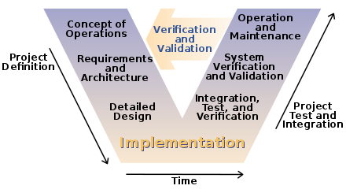

Waterfall Model is also sequential process like V model but it is more strict and rigid as V model has so extent of flexibility.

In Waterfall model the testing activities starts after the completion of development activities while in V model the testing activities starts from the first stage.

Waterfall model is a continuous process while the V model is simultaneous process.

RAD Model:- It is a Rapid Application Development process which is based on prototyping and iterative development with no specific planning involved.

It was first introduced by IBM in 1980’s. The critical feature of this model is use of powerful development tools and techniques.

A software project can be implemented using this model if the project can be broken down into small modules where in each module can be assigned independently to separate teams. This module can finally be combined to form final product.

Development of each modules involves various basic steps as in waterfall model i.e. analysing, designing, coding and then testing.

This model is short time span i.e the time delivery is generally within few months.

This model consists of 4 basic phases:-

1. Requirements planning – It is done using various requirements elicitation.
2. User description – It consist of feedback and building the prototype using developer tools.
3. Construction – It involves the use of powerfully automated tools to transform process and data models into the final working product. All required modification and enhancements are done in this phase.
4. Cutover – All the interfaces between the independent modules developed by separate teams have to be tested properly which is done in this phase and finally released to be acceptance by users.

Advantages –

● Use of reusable components helps to reduce the cycle time of the project.

●Feedback from the customer is available at initial stages.

●The progress and development of the project can be measured through the various stages.

● It is easier to accommodate changing requirements due to the short iteration time spans.

Disadvantages –

● The absence of reusable components can lead to failure of the project.

● The system which cannot be modularized suitably cannot use this model.

● Customer involvement is required throughout the life cycle.

● It is not meant for small .scale projects as the cost of using automated tools and techniques may exceed the entire budget of the project